Frequently Asked Questions

Who is eligible to receive a grant?
Preferred recipients include U.S. Moravian congregations, fellowships, emerging ministries, or agencies. Other ministries are also invited to apply. Last year’s grant recipients may apply for a grant from a different fund this year, but are ineligible to receive another grant from the same fund as previously awarded.

What kinds of projects are eligible?
Matthew 25 and Genesis 2 inspired these funds. Their purpose is to do good in the communities where Moravians have a presence by:

- Providing food and water to the hungry
- Providing shelter and clothing to those in need
- Promoting wellness and healing
- Caring for God’s creation
- Attending to the needs of those in prison
- Protecting and empowering women
- Building awareness and racial reconciliation

While many congregations and agencies are struggling to stay afloat financially, these funds are not intended to cover a church’s budget shortfall or routine operating expenses. Projects that are outwardly-focused, serve the community, and demonstrate love for our neighbors are preferred.

How do I apply for a grant?
Start by sending an email consultation request to Ainsley Davis at adavis@mmfa.info. Ainsley will schedule a discussion to understand the details of the ministry. He will help you match your project to the most relevant Field of Interest Fund and provide you with a copy of the grant application form. You’ll complete the simple, one-page form and attach any supplementary documentation that will strengthen your application. You will need to get sign-off from your pastor and trustee chair (congregation) or executive director and treasurer (agency)
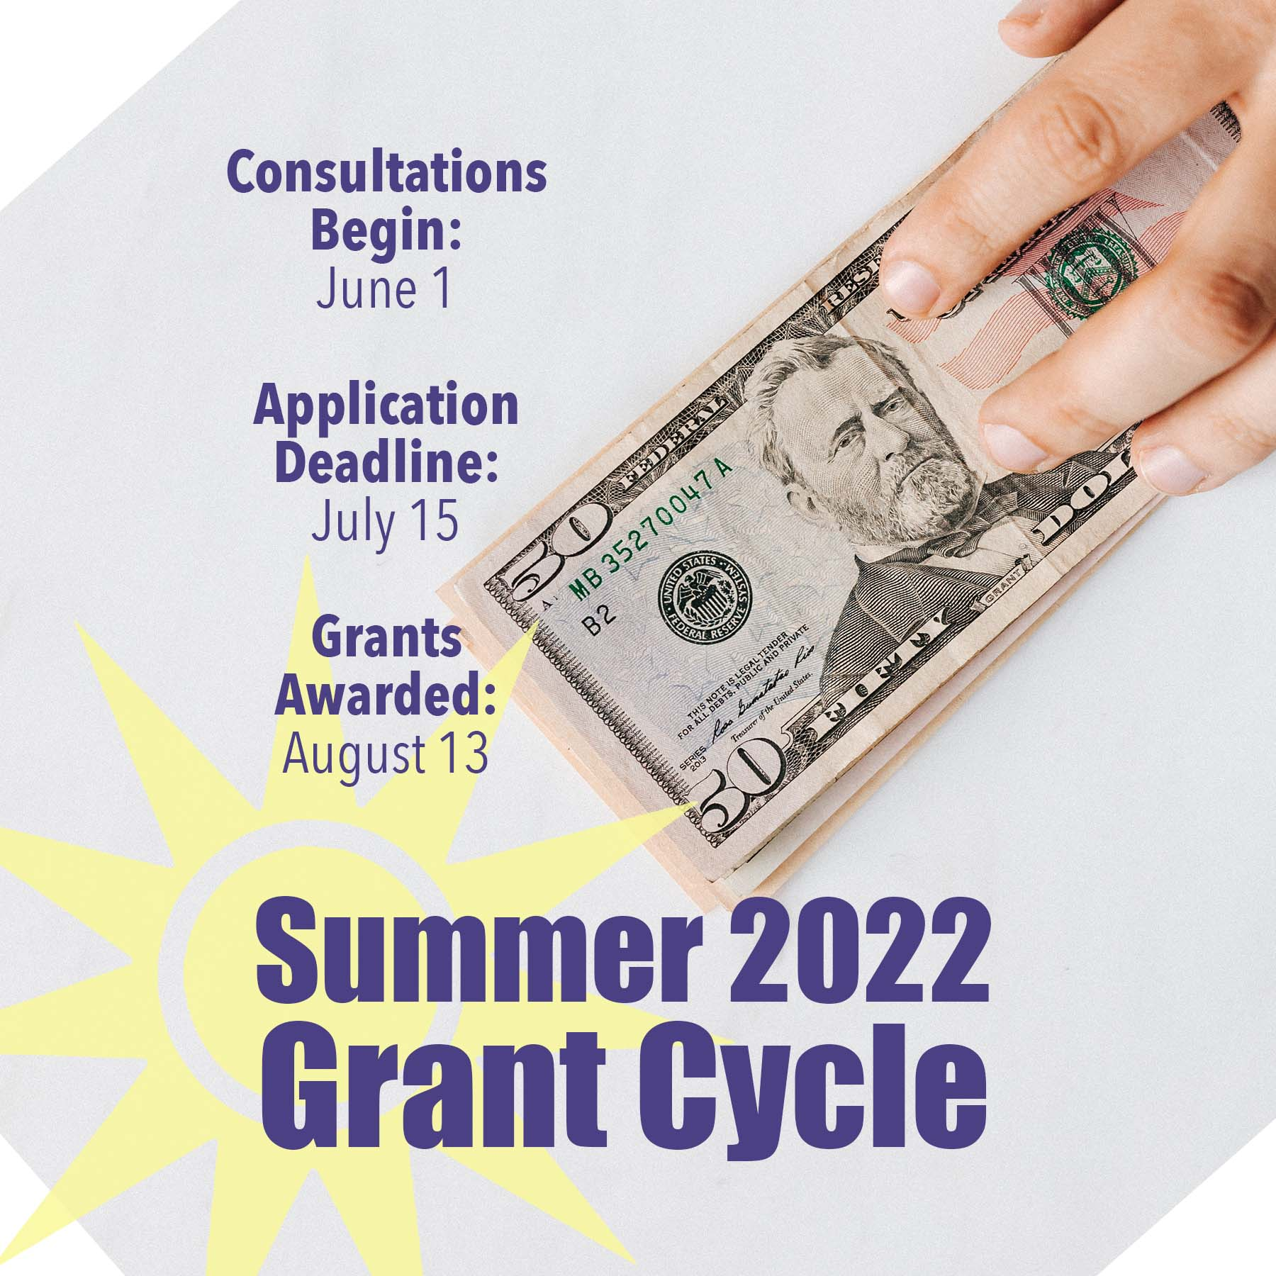

What’s the schedule for the current
grant cycle, Summer 2022?

How are grant recipients chosen?
A Grant Advisory Team, composed of Moravians from the Northern and Southern Provinces, will review all applications and collectively decide on grant awards. They will consider the merit and impact of the project, alignment with the intent of the fund, percentage of the total budget being requested, and many more factors.

Where did the grant money come from?
In 2019, the Moravian Ministries Foundation in America introduced its first Field of Interest Fund on the Moravian Giving Portal. The idea was that donors who had a passion for a particular type of ministry to give in a general way, even without knowing all the agencies that engage in that type of ministry or the details of their programs. Since then, we have created a number of different Field of Interest Funds and Designated Funds. Donors have contributed to these funds and now it is time to put those funds to work. So, the money came from mostly Moravian donors who contributed to the Field of Interest and Designated Funds on the Moravian Giving Portal.

What is expected of grant recipients?
Within one year, The Moravian Ministries Foundation in America will verify that the funding was used according to plan and compare actual to expected outcomes. We’ll want to be able to take photographs (or have permission to use your photographs), interview participants, and publish a story to inspire others.

