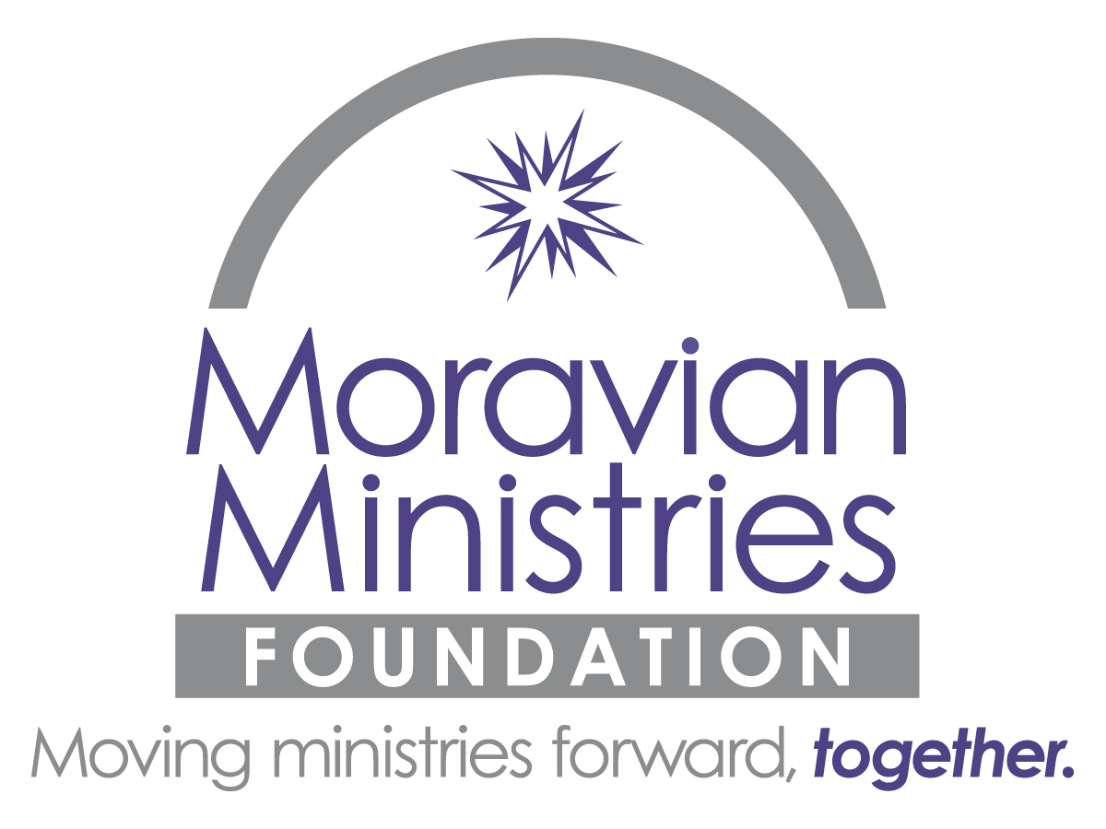
Charitable Donation and Tax Deduction Overview

Public Charities are granted favorable tax status by the IRS: churches, schools universities, the US Government, state and local governments, community chests, community foundations, donor advised funds, and foundations organized and operated only for charitable, religious, scientific, literary, or educational purposes. Our Moravian Ministries Foundation in America is a public charity.

Type of Asset  (Outright Contributions) |  | Income Tax  Deduction |  | Capital Gain  Considerations |  | Effective  Date of Gift | Valuation |  | Substantiation  Required
Cash |  | Up to 60% of the donor’s AGI, with a five-year carryover. |  | None |  | - Cash, check, wire: date of unconditional deliver.  - Checks: date of postmark.  - Credit card: date of charge. | Value = amount of cash |  | - Retain written communication - See endnote 2.  - Gifts<$250: canceled check.  - Gifts>$250 written receipt from charity describing gift and whether goods/services were received by donor.
Marketable Securities |  | - LTCG Securities: Market value up to 30% of donor’s AGI.  - STCG Securities: Cost basis up to 50% of donor’s AGI.  (Both with five-year carryover) |  | None when given to charity – see endnote 3. |  | - Certificates in negotiable form: date of delivery to charity or its agent (postmark date if mailed).  - “Street Name” securities: date of receipt into charity’s acct. | - Listed Securities: value is the mean between the highest and lowest quoted prices on the date of the gift.  - Mutual Funds: value is the public redemption price (NAV) per share on date of gift. |  | - Retain written communication – see footnote 2.  - Gifts<$500: written receipt from charity describing gift and whether goods or serves were received by donor.  - Gifts>$500: receipt from charity, and Form 8283, section A.
Real Estate | - Long-term: current value appraised up to 30% of AGI for unencumbered property. – see endnote 4.  - Short-term: cost basis up to 50% of AGI.  (Both with five-year carryover) |  | No gain reportable unless bargain sale rules apply (see footnote 4), including gifts of mortgaged property. Deduction is not reduced for prior depreciation deductions, unless donor took accelerated depreciation that would have resulted in recapture of ordinary income upon a sale. |  | Date that executed deed is delivered to charity or agent. If mailed, date of postmark. In some jurisdictions, may be date when deed is recorded. |  | Value is determined by a qualified independent appraisal using IRS rules. | - Retain written communication – see footnote 1.  - Deductions above $5,000, donor also needs a qualified appraisal and Form 8283 sections A&B, including declaration of appraiser and done acknowledgement. Environmental assessments may be needed.
Closely-Held  C Corp or S Corp Stock | - LTCG Securities: Market value up to 30% of donor’s AGI.  - STCG Securities: Cost basis up to 50% of donor’s AGI.  (Both with five-year carryover) |  | No capital gain reportable when given to charity. |  | Securities in negotiable form: delivery to charity or its agent; or transfer of securities into charity’s name. |  | - Value is determined by independent appraisal using IRS rules.  - Qualified appraisal required if value is greater than $5,000. | - Retain written communication - See footnote 2.  - Gifts<$250: canceled check.  - Gifts>$250 written receipt from charity describing gift and whether goods/services were received by donor.
Tangible Personal Property | - Gift of LTCG property that charity may put to “use related to its purposes”: market value up to 30% of AGI.  - “Unrelated use”; cost basis up to 50% of AGI. |  | No capital gain reportable when given to charity. |  | Date of delivery of property to charity or agent. |  | Value is determined by qualified independent appraisal:  - For value>$20k, photos must be sent to IRS advisory panels.  - For value>$50k, donor may request “statement of value” from IRS “Art Advisory Panel.” | - Retain written communication.  - Single item, $501 to $5k, Form 8283 section A.  - Single item (or multiple similar items)>$5k, Form 8283 sections A & B with qualified independent appraisal.
Bitcoin | - Held long-term: market value up to 30% of AGI.  - Held short-term: cost basis up to 50% of AGI.  (Both with five-year carryover) |  | No capital gain reportable when given to charity. |  | Securities in negotiable form: date of delivery to charity or its agent. If new certificates are to be issues in the name of the charity: date when security transfer is noted on the books of the transfer agent. |  | Value is determined by a qualified independent appraisal using IRS rules. | - Deductions of <$5k: receipt from charity and “quid pro quo” statement and Form 8283 section A.  - Deductions of $5k and above, requires a qualified appraisal and Form 8283 sections A & B including declaration of appraiser and donee acknowledgement.

For donations of assets not listed in this grid or for any question, please call Chris Spaugh at 336-725-2589.

Endnotes:
- Abbreviations: IRS = Internal Revenue Service (along with various US Treasury rules and regulations); AGI = Adjusted Gross Income; LTCG = Long Term Capital Gains (typically gain on assets held more than one year); STCG = Short Term Capital Gains (typically on assets held less than one year);
- Donor must maintain either a bank record or written communication from the done organization that shows donee’s name, date of contribution, and amount of contribution.
- Step-down Election available for long-term gain property allows donor to deduct cost basis up to 50% of AGI, but may not carry over an excess. The election is binding for the tax year. Any carry overs from prior years must be re-calculated as though election had been made in years in which carryovers arose (the election is irrevocable).
- Contributions of encumbered property (property with a mortgage or debt) are treated as bargain sales and there may be a reduction to the charitable contribution deduction.

